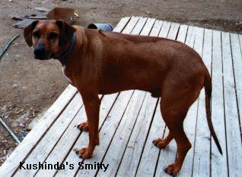

Kushinda’s Smitty

This is Smitty's Story:


I got a call about two months ago from Nancy Krupa in Pittsburgh, PA. Bev had contacted her that her son, Walter had died. Walter was in his 30's. He was Smitty's owner. Walter had requested that Smitty be put down if anything ever happened to him, but mom (Bev) could not do it. So, arrangements were then made through Nancy, my daughter and her roomate, Steph, and Bev to bring Smitty to me. Thanks to all! I, Kimma Hefner, am his breeder. Smitty is out of CH Giorgio and CH Rahisi. Three of his sibling owners are on the Kushinda-List (discussion list on internet) www.RRidgebacks-Kushinda@onelist.com discussion group. CH Rahisi

I have had him now for over two months. He is a very sweet guy. He is neutered. He likes
to play with some of the male dogs I have. He does not pay much attention to the females
and is very frightened of the puppies. He did not stay in a crate when he was with Walter, but he stays in a crate here. I had crate trained him as a puppy. His companions in OH were a cat and an old black Labrador. Bev told me he ate most of the Labs food as well as his own. He was free fed there. He was loose all the time. Unfortunately, he is extremely overweight.

I have been working on the weight problem since I got him back and some of it, is starting to come off. He will need to be on a restricted diet probably for the rest of his life. I have him down to two meals a day now (about four cups daily). He seems to be doing fine. Since he has been fed people food, he is also quite the pathetic beggar when I am eating around him! I also have him on NuVet+ Supplement that I will ask that he be kept on. He is getting an herbal essence for dogs that have or are in stress.

He likes men, but none here. But Tom, the UPS guy, visited him the other day and it made Smitty very happy. He loved the attention. He really would benefit from a home with a man in the house???

He has a very pretty face, black - but now a bit of graying mask, he looks like his mom. Giorgio is pictured on our home page..www.kushinda-ridgebacks.org

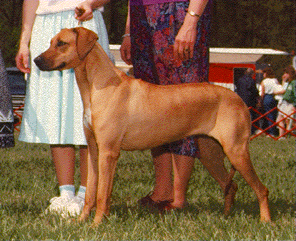

CHAMPION Kushinda's Giorgio Imagemaker, OFA-G - Giorgio

He has a ridge with 6 crowns very nicely placed. Very even tempered, will not bite.

Don’t know how he is with kids. He appears to be happy here. He runs and plays and likes his head rubbed, other than that he doesn’t like to be fooled with.

I am presently looking for a home for him, I will answer any questions you have and be happy for anyone to come and visit with him. I invite any serious inquires.

Kimma B Hefner
PO Box 21
Chambersburg, PA 17201
- 267 2030
Reach us at kushinda@pobox.com

