I said I’d never, ever, do one of these letters, but things change. I just realized that December is two thirds over and I haven’t had time to do any shopping, let alone Christmas cards. OK, so I never do shopping until the last minute, but I usually do the cards on time. So I figured I’d just fire up my new dandy computer, whip off a very witty letter, change a few things to make it seem like a personal note to everyone, and quickly mail off my cards with the said letter enclosed. Unfortunately my printer doesn’t want to talk to my new computer – it liked the old better. New plan – if I have your email address, you will here from me by Christmas. If not, I guess this will be a New Years letter. Between the dogs and the llamas, I’m never bored.

CHRISTMAS 2005

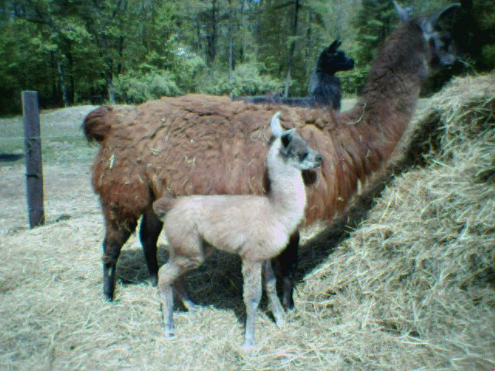
The latest addition, Houdini, arrived in May.
This will probably be the last cria born here. These animals live to be 20 – 25 years old, so I should think about winding down!
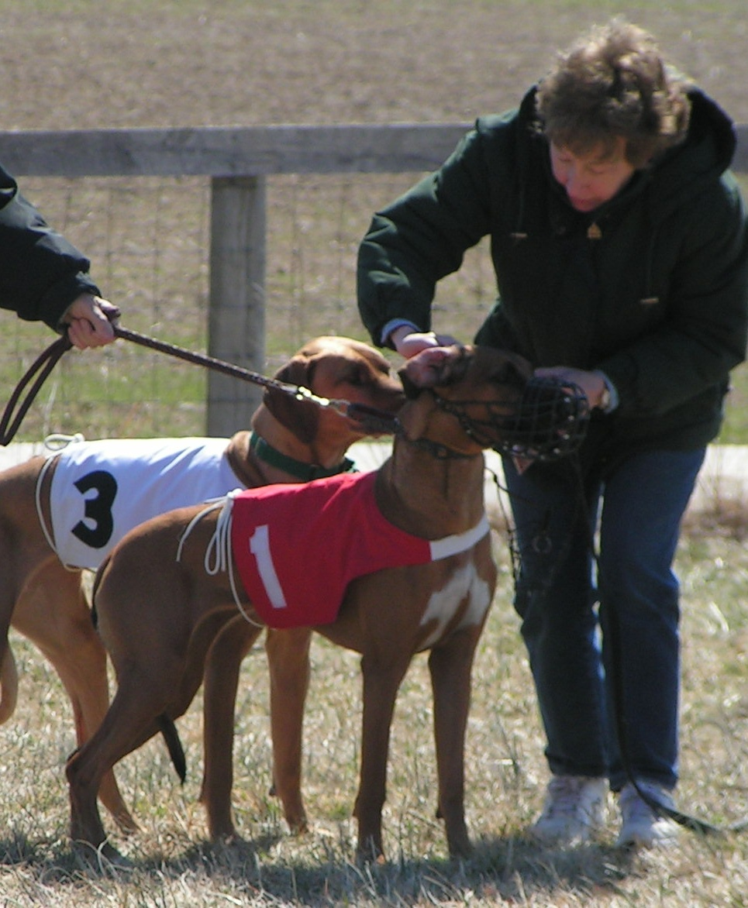
The dogs continued to display their prowess on the racing circuit, keeping me busy through the spring before the hot weather sidelined us.
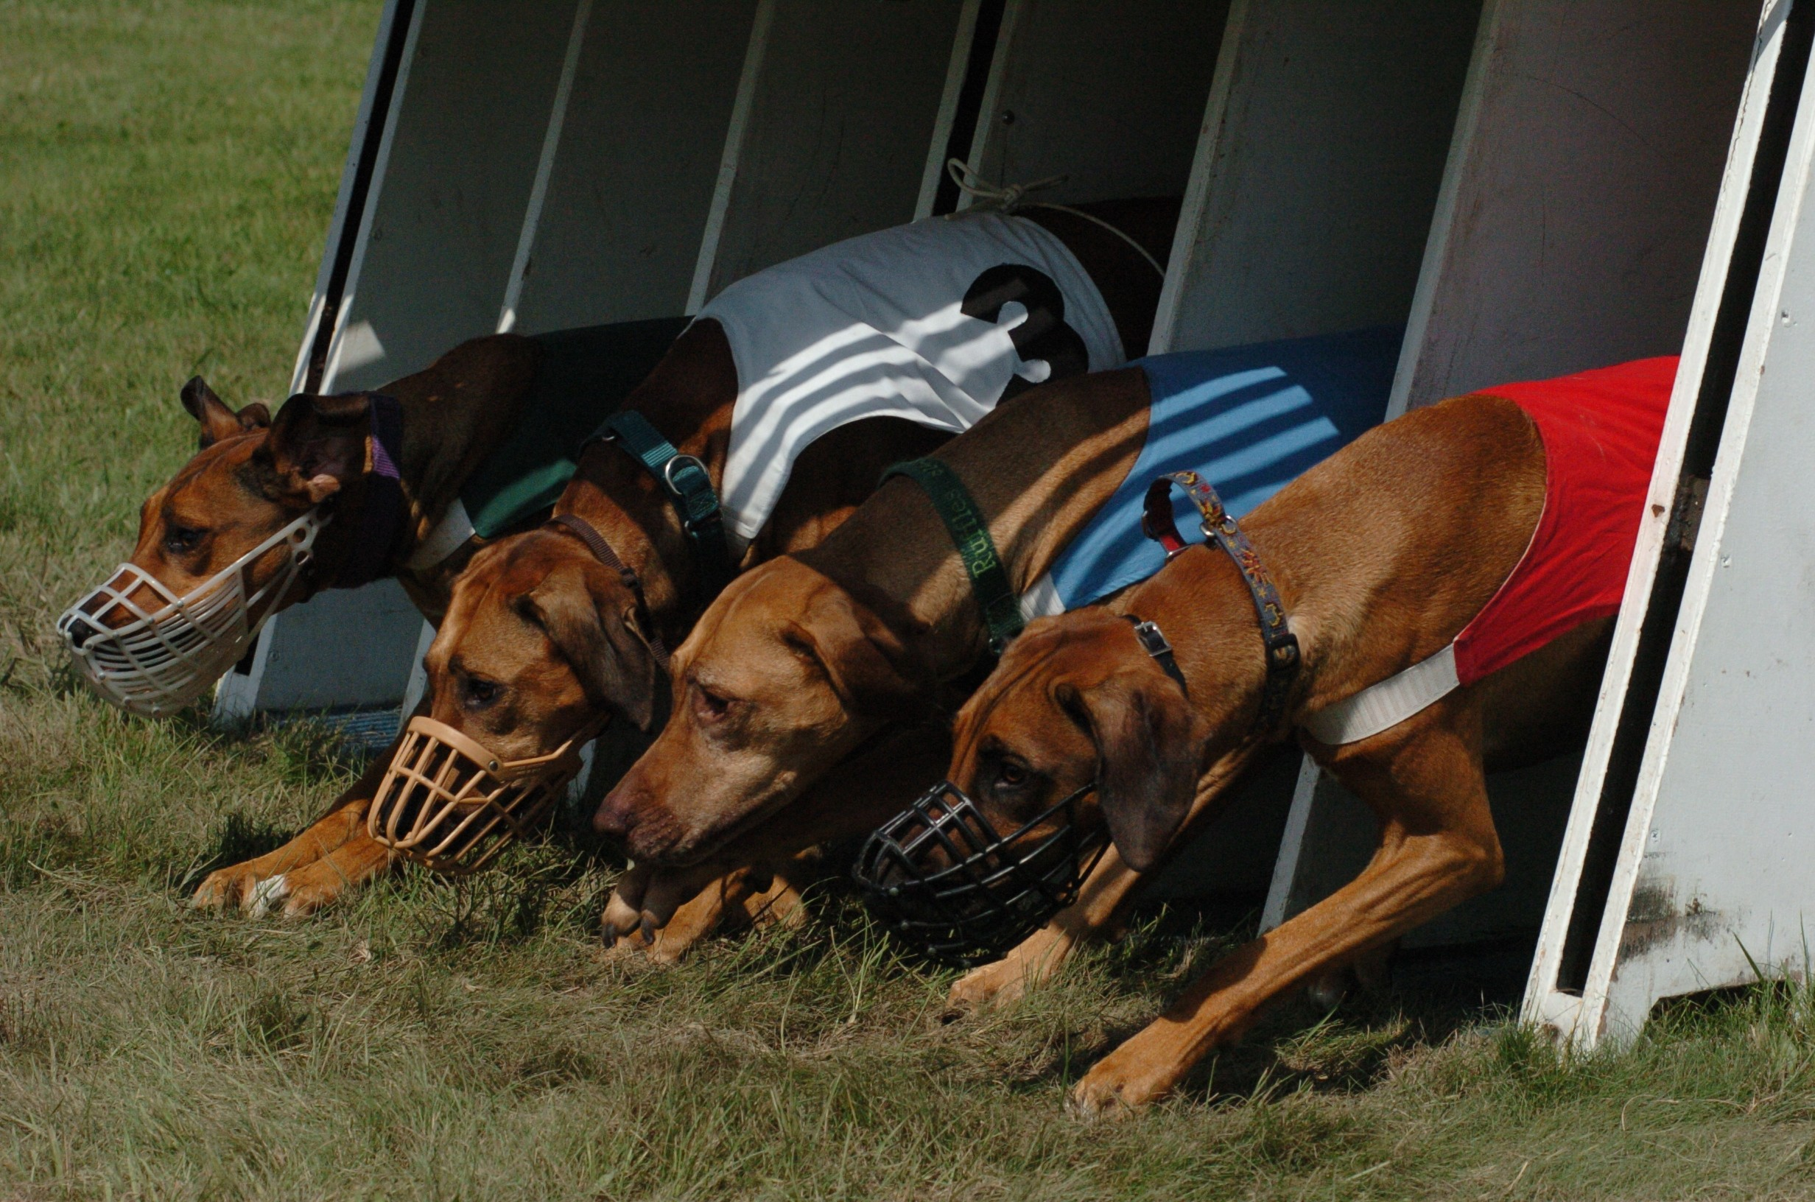

I also continued my venture out into the world. Last year I traveled to Ireland with my college roommate. We had a great time wandering around the countryside, seeing the sights and interacting with the locals. Driving in that country was a challenge, but we managed to do it without any fatalities (unless you count hubcaps).
This year I sampled Asia. I went with a small tour group to Thailand and I had a super time. I met some great people, saw some wonderful country, and experienced a totally different culture. As the pictures show I can make friends anywhere:
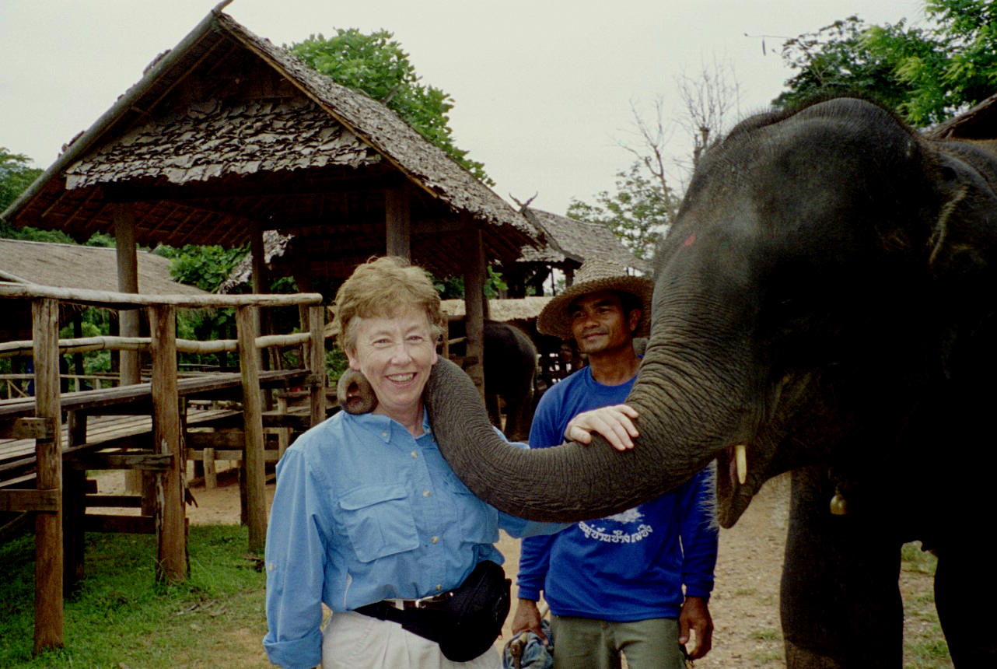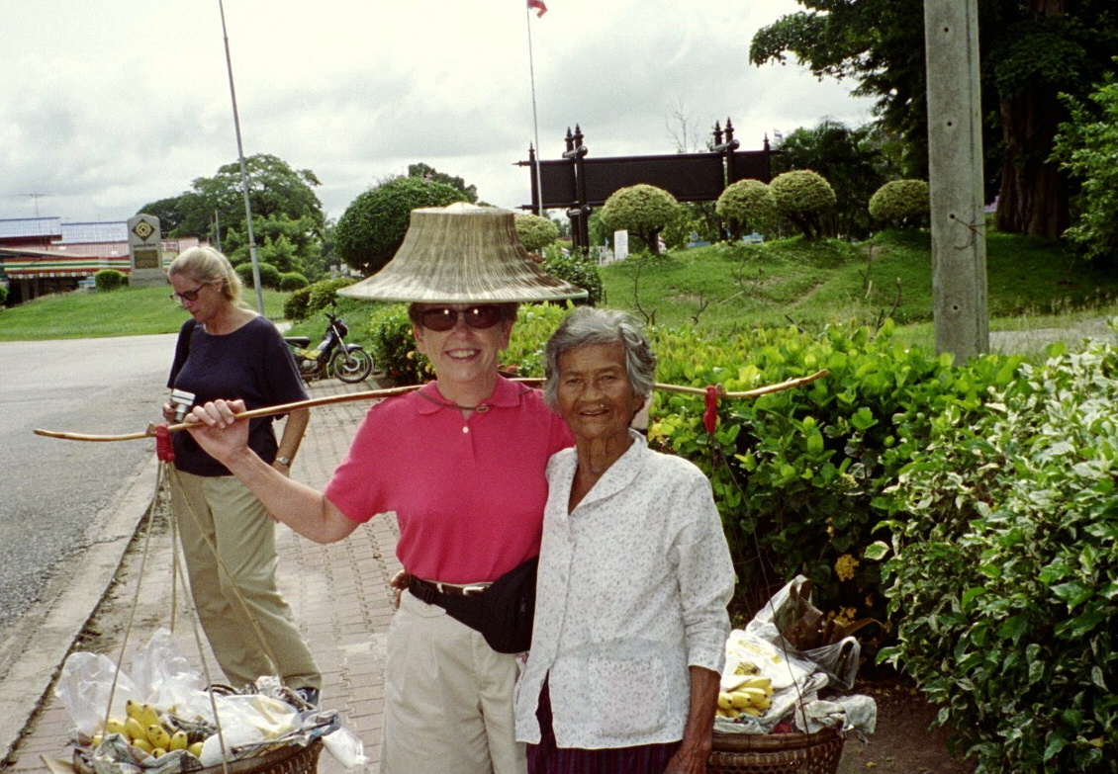

I’m really looking forward to my next adventure – I’m thinking of doing an African safari next Fall.
As another step in preparing for the future (i.e. retirement), I volunteered to usher for the Center for the Performing Arts at PSU. Normally you spend 2 –3 years on the waiting list, but I called when they were desperate for help. I was handing out programs the next weekend! I didn’t really want to do this quite yet, but I couldn’t pass up the opportunity and I have seen some great performances (I also look kind of cute in my bow tie and tuxedo vest – sorry, no picture).
That’s all the news that’s fit to print, so I’ll wish you a Merry Christmas and a Happy New Year.
Love and Good Health,

Donna

