PEE-DEE’

OUR NEWEST BEST IN FIELD – May 29th , 2005 !!!

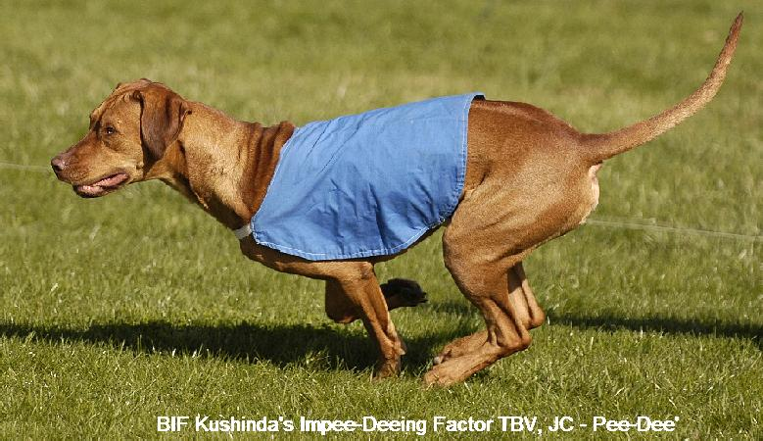

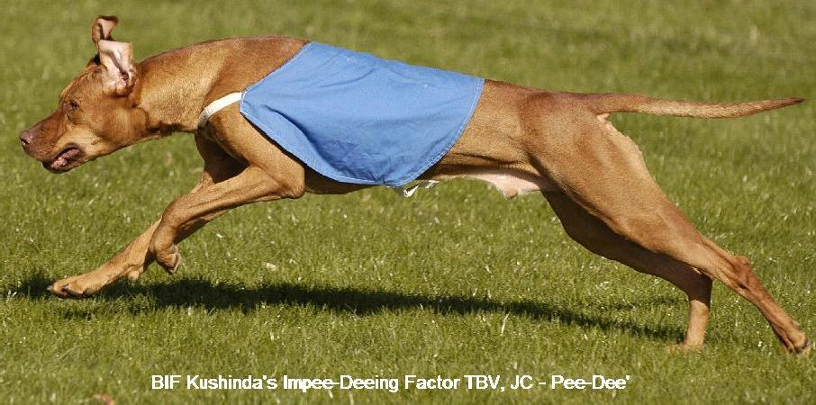

BREEDERS: Dr. Kammi Kai Hefner  Kimma B. Hefner
OWNERS: Dr. Kammi Kai Hefner  Kimma B. Hefner  Karrie Dee Hefner

