The Lion Hounds of Kushinda Proudly Present

GRACIE
NEWS FLASH
then on to a
3 point MAJOR under
Judge
Mr. Neville Newton
on 11/19/05
KUSHINDA’S GRACEFUL PRAIRE ROSE HAC

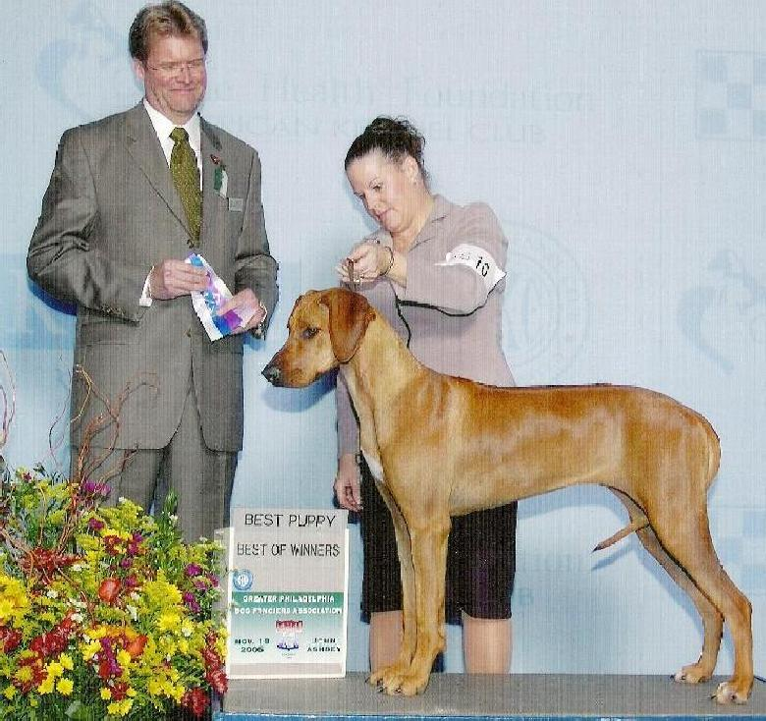
Thank you
Judge Mr. Randy E. Garren

Breeders: Dr. Kammi Kai Hefner & Kimma B. Hefner Presented by: Patricia A. Wieland

OWNERS: DR. KAMMI KAI HEFNER • PATRICIA A. WIELAND •
KIMMA B. HEFNER • KARRIE DEE HEFNER

www.kushinda-ridgebacks.org • Kushinda@pobox.com • 717-267-2030 • 304-216-3617

